Contestant Number: ____________________
Time: ___________________
Rank: _______________



INTEGRATED OFFICE APPLICATIONS
(215)

NATIONAL 2021

Production Portion:

Job 1: Performance Review Form (130 points)

Job 2: Content Controls ( 55 points)

Job 3: Spreadsheet (175 points)

Job 4: Link Performance Review and Results (170 points)

TOTAL POINTS (530 points)

Test Time: 90 minutes

GENERAL GUIDELINES:
Failure to adhere to any of the following rules will result in disqualification:
- Contestant must hand in this test booklet and all printouts if any. Failure to do so will result in disqualification.
- No equipment, supplies, or materials other than those specified for this event are allowed in the testing area. No previous BPA tests and/or sample tests (handwritten, photocopied, or keyed) are allowed in the testing area.
- Electronic devices will be monitored according to ACT standards.

EXAM GUIDELINES:
- Ensure this test booklet contains Jobs 1-4
- Key all jobs according to the instructions given.
- Correct any and all formatting, spelling or grammar errors. Use the formatting guide in the Style & Reference Manual.
- Your name or initials should not appear on any work you submit. Use your contestant number in any occasion you would normally key your reference initials.
- In the lower right hand corner of ALL work submitted (unless otherwise specified) key your contestant number and job number.
- If you complete the event before the end of the time allotted, notify the proctor. Time could be considered a factor in determining a winner when there is a tie score.
- Place your scoring sheet on top of your Jobs. Jobs should be placed in numerical order.

PRODUCTION STANDARDS
0 Errors | 100 Points
1 Error | 90 Points
2 Errors | 70 Points
3 Errors | 50 Points
4+ Errors | 0 Points

Job 1 – Performance Review Form | Possible Points | Points Awarded
Production Standards  0 errors - 100 points, 1 error - 90 points, 2 errors - 70 points, 3 errors – 50 points, 4 or more errors – 0 points | 100
Cell formatted to 0.2” tall and center aligned vertically | 10
Creativity (eye-catching and easy to read) | 10
Constant # and job # in left footer | 10
Total | 130
Job 2 | Possible Points | Points Awarded
Employee Name – Rich Text Control Added | 5
Department – Drop-Down List Control Added | 5
Review Period – Date Control Added | 5
Employee – Text Form Control Added | 5
Job Title – Rich Text Control Added | 5
Date – Date Control Added | 5
Manager – Drop-Down List Control Added | 5
To – Date Control Added | 5
Supervisor Comments – Rich Text Control Added | 5
Constant # and job # in left footer | 10
Total | 55

Job 3 - Spreadsheet | Possible Points | Points Awarded
Production Standards  0 errors - 100 points, 1 error - 90 points, 2 errors - 70 points, 3 errors – 50 points, 4 or more errors – 0 points | 100
Inserted 3D Clustered Column chart for Average Rating | 10
Printed Justin, Melissa, and Larsen’s worksheets – 5 points for each printout | 15
Column and Row Headings showed | 10
Worksheets landscaped and fit to one page | 10
Printed Larsen Smith worksheet in formula view | 10
Correct formula used to calculate average rating | 10
Constant # and job # in left footer and sheet tab name in right footer (all or nothing and must be on all worksheets) | 10
Total | 175
Job 4 | Possible Points | Points Awarded
Production Standards  0 errors - 100 points, 1 error - 90 points, 2 errors - 70 points, 3 errors – 50 points, 4 or more errors – 0 points | 100
All information is visible | 10
Corrected identified department manager | 10
Link Melissa’s rating information from supervisor and peers | 10
Link Melissa’s rating summary | 10
Imbedded Melissa’s rating chart | 10
Printed Melissa’s performance review so it fits on one page | 10
Constant # and job # in left footer | 10
Total | 170
TOTAL | 530

Job 1 – Creating Basic Performance Review Form
Using the information in the table below create a performance review form. Format all rows to at least 0.2” tall and vertically aligned center of the cell. Be creative with your design. Print completed form.

Professional Business Associates
Performance Review
Employee Information
Employee Name |  | Date
Job Title |  | Employee ID
Department |  | Manager
Review Period |  | To
Rating
Rating Summary
Rating Chart
Written Evaluation
Supervisor Comments

Job 2: Form Content Controls

Using the Performance Review created in Job 1 add the following form controls. Print form with controls added.

Field Name | Content Control Information
Employee Name | Rich Text
Department | Drop-Down List  - Title – Department  - Add the following Departments  - Financial Services  - Information Technology  - Human Resources  - Marketing  - Administrative Support
Review Period | Date Control
Employee ID | Text Form Field  - Text Type - Number  - Maximum Length - 4
Job Title | Rich Text
Date | Date Control
Manager | Drop-Down List  - Title – Manager  - Add the following Departments  - Harvey Rosen  - Tom Carlson  - Julie Smith  - Roger Meyer  - Edna Renick
To | Date Control
Supervisor Comments | Rich Text

Job 3: Spreadsheet

Create a worksheet in Excel that you can enter numerical results for the performance review. Make sure each employee is on a new sheet. In addition to Contents ID and Job # in the right footer, also place the sheet tab right footer. You will also need to create a 3D Clustered Column chart with no legend that shows the average rating the results.

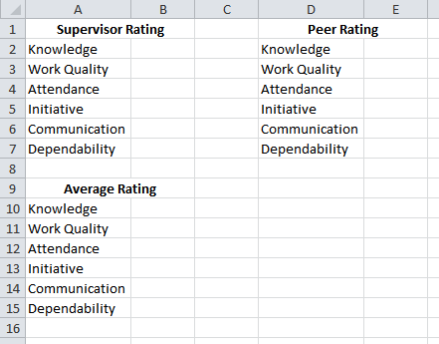

- Create a formula to calculate the average of supervisor and peer rating for each category.
- Create 3 copies of the starting worksheet. Label each sheet as follows: Justin Wilson, Melissa Kaiser, and Larson Jones. The data is as follows:

Justin Wilson Rating Information
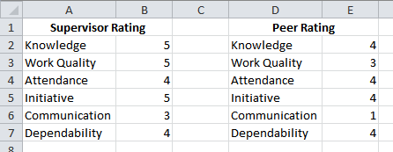

Melissa Kaiser Rating Information
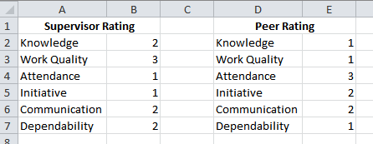

Larsen Smith Rating Information
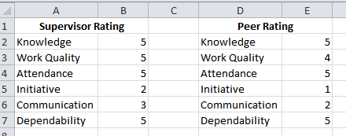

- Print all worksheets so they show column and row headings, are landscaped and fit to one page. Make sure all information is visible.
- Print formula view for Larsen Smith so it show column and row headings, are landscaped and fit to one page. Make sure all information is visible.

Job 4: Link Performance Review and Results

Link the performance results for Melissa Kaister in MS Excel to the Performance Review form in MS Word. All areas of the evaluation form should be filled in.

- Below is the information you need to complete the Employee Information and Written Evaluations Section.

Field Name | Information
Employee Name | Melissa Kaiser
Department | Information Technology
Review Period | 3/20/2021
Employee ID | 9874
Job Title | Sales Agent
Date | 4/4/2017
Manager | Look up in Style and Reference Manual
To | 3/24/2021
Supervisor Comments | Melissa needs to develop a more conventional work ethic.

- Link the following sections from MS Excel
  - Rating – make sure to include section titles
  - Rating Summary – make sure to include section titles
  - Rating Chart

- Make sure all information is visible on one line and performance view fits on one page.

- Print Melissa Kaiser’s completed Performance Review

